# **PRODUCT REQUIREMENT DOCUMENT**

## Customer Churn Analysis and Prediction - beatit.ai

### **Overview**

**beatit.ai** is one of the music streaming startups in South Asia. They offer their services to millions of people, supported by advertising and paid subscriptions. They use free or discounted trials to entice a customer who arrives on their platform. However, with the arrival of some new competitors, the company’s churn rate is rising.

The task at hand is to predict the propensity of customer churn for the company. In the project, we would like to build a model that can predict the customers at risk of cancelling the beatit.ai music streaming service based on available data, which is the user's past activity and interaction logs with the service. This will assist in identifying the probability of customer churn in the future so that preventive action can be taken.

The purpose is to provide the marketing team with insights into why a customer is choosing to leave, which will assist in identifying the probability of customer churn in the future so that preventive action can be taken. An example of a preventive action could be sending an email to the customers who are identified as having a high probability of churn and offering them a better subscription deal.

The marketing team wants to engage with potentially churning customers to win their loyalty back. To engage as efficiently as possible with the customers, they want to do this in an automated way.

The marketing team needs help in answering the following questions:

* Can you tell us which customers are likely to leave us within the next month?
* Can you provide any insights into why they are not continuing their subscription?

## 

## 

### **Relevance**

1. The company has been in business for many years and has been putting a lot of effort into marketing to acquire new customers. beatit.ai must incur increasingly expensive advertising buys and entice subscribers with free or discounted trials. However, all these techniques frequently fail to convert to full-priced subscriptions.

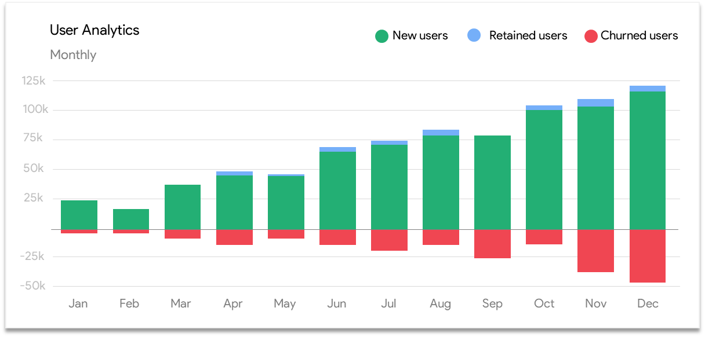

1. The company is losing 7% of its customer base monthly, and each user is offered a range of discounts as a corrective action. The team considers every user as equally important, as it is unaware of the possible reasons for customer churn.

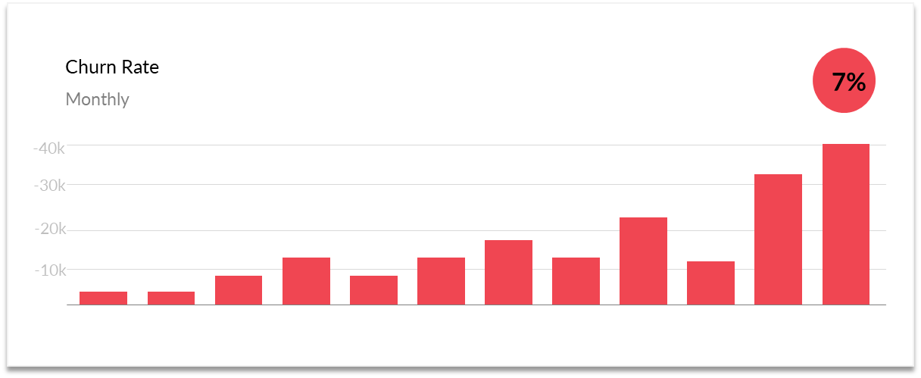

To resolve this issue, three primary strategies have been proposed to generate more revenue:

1. Acquire new customers
2. Upsell existing customers
3. Increase the retention period of customers

However, considering the return on investment (RoI) of each approach into account has shown that the third strategy is the most profitable. Retaining an existing customer costs much less than acquiring a new one and is much easier than the upselling strategy.

With this strategy, the company has to decrease the potential of customer churn where the customer is moving from one provider to another.

### **Stakeholder Requirements**

This problem could be approached with an ML solution, where the objective is to enable preventive actions to be taken before a customer churns. Using the historical churn data that the company has collected through the years, the ML model can predict which customers will likely leave the service within the next month. However, before building a model, we need clarity regarding the ML system's overall objectives.

The overall requirements, gathered from different stakeholders, can be broken down into three different categories:

| Must Have​ | Good to Have​ | Out of Scope​ |
| --- | --- | --- |
| The output is a machine learning model that can predict customer churn​.  The model should be capable of reducing the churn by 2-3%​.  The model should be able to adapt to the new dynamic behaviour of the user​.  The prediction report should be sent one month prior to the actual churn to enable corrective action to be taken.​ | The model results should be interpretable to make it possible to analyse the reasons for customers' exit.  A weekly report should be sent via email containing the details of users who are about to churn​​. | The model should be capable of reducing churn by 7%.​  A completely automated (no manual intervention) system must be developed in 6 months​.  The model should also help select optimum discounts, which can be sent to a user who is about to churn.​​  ​ |

We can narrow down the above requirements into the following core business objectives that can help us prevent customer churn:

* Create a machine learning model that can predict customer churn and​ is capable of reducing the overall monthly churn by 2-3%.
* Build a semi-automated MLOps solution to adapt to the dynamic behaviour of users.
* The business team wants interpretability in the model results for analysing the reasons for customer exit, which can be used for product improvement.
* The marketing team wants to predict churn one month before the actual churn occurs to have sufficient time for proactive action with the relevant customers. The 1-month window has been selected so that the team has enough time to re-engage with users at risk of churning with incentives and prevent them from cancelling their subscription.

For example, given the model's accuracy, the company has an improved customer understanding when discussing the range of discounts offered to customers who may leave. For example, to keep a customer from churning, does the company need to offer a 10% discount, 20% discount or even a 30% discount?

Remember that a bigger discount requires more accurate modelling in general. You should find a discount rate to maximise the total revenue with known accuracy. The cost of sending discounts (if any) should also be considered.

### **Suggested Solution**

Based on the propensity of a user to churn, we can identify the next best action to take for each user through the following steps:

1. Calculate the churn probability of a user within the next 1 month using an ML model.
2. All probable churned users should be assigned an action category (bucket) – **A, B or C –** based on their probability:
   * 1. 'A' is the bucket with the highest probability and 'C' is the lowest.
     2. The marketing team can then use these buckets to assign discounts to the respective customers.
        1. A (users who will churn anyway): the team can send across emails (personalised or generic).
        2. B (users who are on the fence): the team can offer the highest discount rates (1-month free subscription).
        3. C (users who will be retained anyway): the team can send across personalised emails.

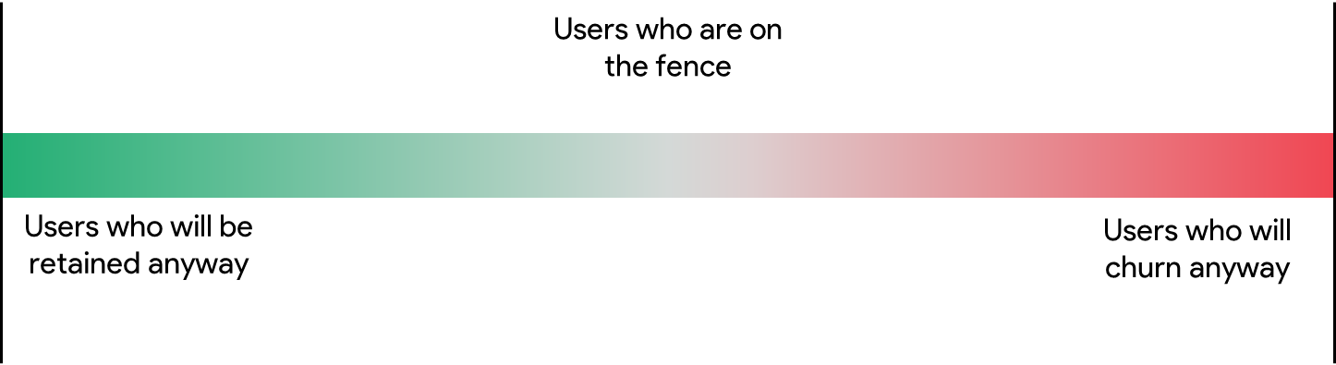

User’s propensity to churn.

**Factors to keep in mind**

1. **How is the churn of a user defined?**

*The definition of 'churn' is no new valid service subscription within 30 days after the current membership expires.*

1. **Are we factoring involuntary churn as part of this project?**

*We are not considering involuntary churn as part of the project, and its objective.*

*Note: Involuntary churn occurs when a customer’s payment attempt fails, leading to subscription cancellation.*

1. **What is the overall business objective?**

*The overall objective of beatit.ai is to retain its customer base so that the overall ARR (annual revenue rate) can be increased.*

**KPIs**

| KPI | Current Value | Average Reduction |
| --- | --- | --- |
| **Monthly churn rate** | 7% | 2-3% |